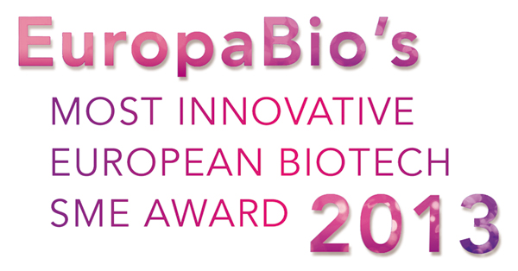

## About the “Most Innovative Biotech SME Award”

EuropaBio’s Most Innovative Biotech SME Award aims to reward European Biotech SMEs that have developed innovative solutions to technical, social and environmental problems.

The award will be presented during the European Biotech Week at an event in Brussels showcasing innovative Biotechnology in Europe. Attendees will include senior European policy makers such as MEPs Dr Kay Swinburne and Dr Philippe De Backer, G. Steven Burrill, Founder and CEO of Burrill & Company, company CEOs as well European Venture Capitalists and SME funding experts.

**Winning the Most Innovative Biotech SME Award would entitle your company to:**

* **Visibility within the EU media**
* **Visibility to EU policy makers and funding experts**
* **A cash prize of €10 000**
* **Two years free membership of EuropaBio (worth more than €5000)**

**Should your company be shortlisted as a nominee for the prize you will also be requested to attend the event in October, offering you the opportunity to network and present your activities to the high-level audience .**

## About EuropaBio

EuropaBio is the European Association for Bioindustries, bringing together bioscience companies from all fields of research and development, testing, manufacturing and distribution of biotechnology products. It has 56 corporate members, 14 associate members and Bio Regions and 19 National Biotechnology Associations- representing some 1800 small and medium sized enterprises across Europe.

Its members are involved in research, development, testing, manufacturing and commercialisation of biotechnology products and processes, and have a wide range of activities: human and animal health care, diagnostics, bio-informatics, chemicals, crop protection, agriculture, food and environmental products and services.

To learn more visit our website: [www.europabio.org](http://www.europabio.org)

## About the judging panel

All applications will be assessed by a panel of highly-qualified judges, including internal EuropaBio representatives and external experts. The judging panel will include:

* G. Steven Burrill, Founder and CEO of Burrill & Company
* Dr Kay Swinburne, MEP
* Dr Philippe de Backer, MEP
* Tom Saylor, CEO, Arecor and Chair of the EuropaBio SME Platform
* Nathalie Moll, Secretary General of EuropaBio

## About the Use of Your Application

Your application will only be used for the purposes of assessing your eligibility for the Most Innovative Biotech SME award. Any information gathered from these applications may be rendered anonymous and used by us for statistical purposes. We will seek your permission prior to using any identifiable or quotable information.

## About SMEs at EuropaBio

EuropaBio has set up a specific SME Platform which focuses its activities on developing policy recommendations to respond to the challenges and financial constraints that biotech SMEs face in Europe, and on optimising EU and member state funding instruments for biotech SMEs.

Our SME Platform brings together European Regulators, CEOs of SMEs, National Biotech Associations, venture capitalists and private banks, European financial institutions and other interested stakeholders.

For further information, please contact: Rosalind Travers: [r.travers@europabio.org](mailto:r.travers@europabio.org)

## *- Application Form -*

## *Deadline 10th June 2013*

## General Information

1. Name of Company:
2. Date of Incorporation:
3. Name of CEO:
4. Contact person name:
5. Email and phone number of contact person:

## SME Classification Criteria Compliance

In order to be considered for the EuropaBio SME award your company must qualify as an SME under the standard EU SME definition. For Further information please click the following link.

<http://ec.europa.eu/enterprise/policies/sme/files/sme_definition/sme_user_guide_en.pdf>

Please answer the following questions to confirm that your organisation falls within the European SME definition.

1. Is the primary location of your companies operation within Europe?

Yes / No Which country?

1. Is the total number of employees within your organisation equal to or below 250 employees (as defined by your national law)? Please specify the number of employees you have.

Yes / No Number of Employees:

1. Is your Annual Turnover less than €50 Million? Please give an estimate of your annual turnover.

Yes / No Estimation of Annual Turnover:

1. Do you believe your organisation fulfils the European criteria to be classified as an SME?

Yes / No

## Response to Social/Environmental Needs & Creation of Innovative Solutions

An SME needs to pre-empt or respond to societal and/or environmental needs in order to create innovative solutions to the problems we face. Innovation and creativity are critically important for the strength and success of high-tech SMEs. Please answer the questions below, in each case in 800 words or less, in order to demonstrate your achievements in this area. Please be aware that we are unable to accept any additional documentation in support of your application. Therefore, your application will be judged solely on the information given in responses below.

Explain the technical, social and/or environmental challenges addressed by your company.

How do you believe this was creative, innovative, effective and important for society and/or the environment?

## Business Strategy Evaluation

A solid business strategy is key to the success of an SME. Sustainability in such a business strategy is also important in terms of longevity and company financial health. The following questions will ask you to detail some of the challenges that you have faced and overcome, outlining the solutions you have applied (please answer the questions below in 400 words or less).

1. Summarize your business strategy for the next few years ahead

1. Explain how your business strategy is sustainable

1. Describe the challenges and successes in raising capital over the last 24 months

1. Explain how you have managed intellectual property (IP) challenges, the importance of IP to your strategy and how you have successfully addressed these needs

1. Please detail any problems that you faced in setting up or running your SME and explain how you overcame them

## *Please send your completed application form to the below address*

## *by 10th June 2013*

*Rosalind Travers*

*EuropaBio*

*Avenue de l’Armée 6*

*1040 Brussels, Belgium*

***Or by email or fax to:*** *r.travers@europabio.org*

***Fax: +****32 2 735 4960*

***Phone:*** *+32 2 739 11 73*